**Preston’s College hosted the Construct at Preston event in March 2018. At the event pupils from six high schools were able to try tasks in different trade disciplines in the construction industry.**

The schools competed in a number of interactive challenges that linked to different trades in the construction industry and provided pupils the opportunity to learn about different trades and careers within the construction industry. The challenges acted as a tool to introduce young people to the industry by teaching them various tricks of the trades through a practical, hands-on experience.

Corpus Christi’s Year 10 team won the competition with Ashton Community Science College second and Longridge High School third.

Mark Taylor, head of school for Construction & the Built Environment at Preston’s College, concluded: “The event was aimed at introducing young people into the construction industry by providing experience of various professional and trade pathways available.”

The Central Lancashire Construction Hub coordinated the event in partnership with the Lancashire Enterprise Partnership (LEP) and the three local authorities of central Lancashire.

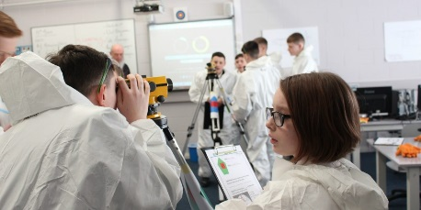

**Appendix 3 - City Deal employment and Skills Case studies**

|  |  |
| --- | --- |
| Image result for preston college logo  **Construct at Preston** |  |